Project Design Phase-II
Data Flow Diagram & User Stories

Date | 07 March 2026
Project Name | Visualization Tool for Electric Vehicle Charge and Range Analysis
Maximum Marks | 4 Marks

Data Flow Diagrams:
A Data Flow Diagram (DFD) is a traditional visual representation of the information flows within a system. A neat and clear DFD can depict the right amount of the system requirement graphically. It shows how data enters and leaves the system, what changes the information, and where data is stored.

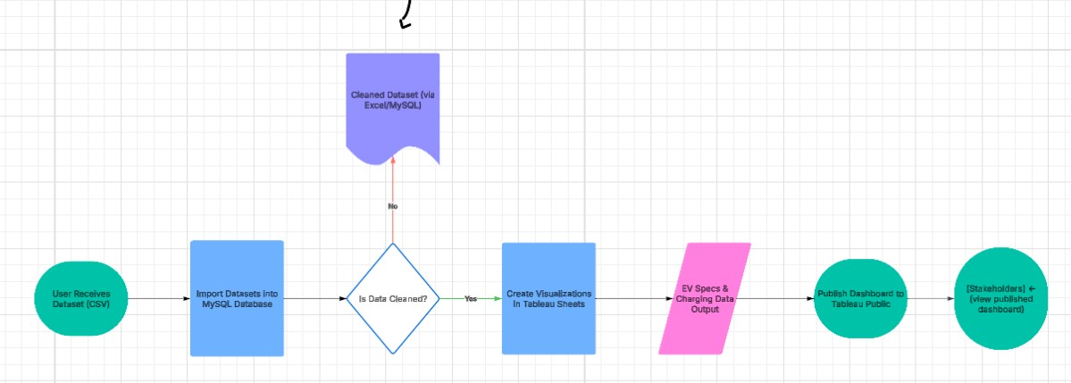

Example: DFD Level 0 (Industry Standard)

User Stories

User Type | Functional Requirement | User Story No. | User Story | Acceptance Criteria | Priority | Release
EV Buyer | Explore EV models | USN-1 | As a user, I can view EV car models sorted by brand, price, or top speed | I can filter EV models and view details | High | Sprint-1
EV Buyer | Compare performance | USN-2 | As a user, I can compare cars by speed and efficiency | I can identify top performing EVs | High | Sprint-1
Policy Analyst | View Charging Station Map | USN-3 | As a user, I can see EV charging stations on a map | I can view stations by region and type | High | Sprint-1
EV Buyer | Filter by body style | USN-4 | As a user, I can filter EVs by body style | I can view only SUVs, Hatchbacks, etc. | Medium | Sprint-2
EV Buyer | See Global vs India summary | USN-5 | As a user, I can view India vs Global EV summary cards | I can switch between India and Global metrics | Medium | Sprint-2
Admin / Analyst | Upload or update dataset | USN-6 | As an analyst, I can update car data into  MySQL | Dashboard reflects new data | Low | Sprint-2

